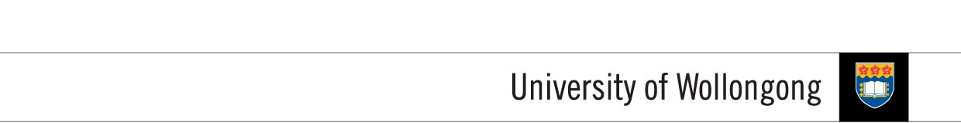

**FACULTY OF INFORMATICS**

|  |  |  |  |
| --- | --- | --- | --- |
| **SUBJECT’S INFORMATION:** | | | |
| Subject: | CSCI124 Applied Programming | | |
| Session: | July 2014 | | |
| Programme / Section: | J766SENG (SE) / J766CS53 (MGD) / J766CS42 (DSS) | | |
| Lecturer: | Ms. Siti Hawa | | |
| Coursework Type  *(tick appropriate box)* | ❑ Individual Assignment ❑ Group Assignment ❑ Project  ✓Lab Task ❑ Seminar / Tutorial Paper ❑ Others | | |
| Coursework Title: | **Lab Task 10** | Coursework Percentage: | 2% |
| **ASSESSMENT CRITERIA:** | | | |
| Correctness | All programs should produce the correct result as stated in the specification. | | |
| Coding | Programs should use appropriate control structures and data structures correctly based on what have been covered in the class and stated in the specification. Necessary input validations should be done. | | |
| Readability | Appropriate comments are included. Meaningful identifiers used. Proper indentation and line spacing used. | | |
| Well formatted output | Output should be well formatted with appropriate messages displayed. Numbers are shown with appropriate precision. | | |
| **SUBMISSION:** | | | |
| All completed work should be submitted online through Moodle before or on the due date provided.  **SUBMIT AS EARLY AS POSSIBLE. YOU CAN RE-SUBMIT LATER IF NECESSARY. ONLY THE LATEST SUBMISSION WILL BE MARKED.**  **IF YOU SUBMIT YOUR ASSIGNMENT TWICE, ONE SUBMMISSION BEFORE THE DUE DATE AND ANOTHER AFTER THE DUE DATE, THEN YOU WILL BE PENALIZED FOR LATE SUBMISSON.** | | | |
| DUE DATE: | **WEEK 16** | | |
| **PENALTIES FOR LATE SUBMISSION:** | | | |
| Penalties apply to all late work, except if student academic consideration has been granted. Late submissions will attract a penalty of 25% of the assessment mark per day including the weekend. Work more than (3) days late will be awarded a mark of zero. | | | |
| **PLAGIARISM:** | | | |
| **When you submit an assessment task, you are declaring the following**   1. It is your own work and you did not collaborate with or copy from others. 2. You have read and understand your responsibilities under the University of Wollongong's policy on plagiarism. 3. You have not plagiarised from published work (including the internet). Where you have used the work from others, you have referenced it in the text and provided a reference list at the end ot the assignment.   Plagiarism will not be tolerated. Students are responsible for submitting original work for assessment, without plagiarising or cheating, abiding by the University’s policies on Plagiarism as set out in the University Handbook under University Policy Directory and in Faculty handbooks and subject guides. | | | |

**COURSEWORK SPECIFICATION**

**OBJECTIVES:**

The aim of this lab class is to provide you the experience with programming using stack.

**TASKS:**

A stack is collection that allows items to be inserted in a LIFO order. A stack can either be implemented using a linked list or an array. In this lab task, you are provided with a stack implementation using a linked list and you are required to use it in your program.

Your task is to write a program to evaluate an arithmetic expression in postfix notation using the stack class provided to you. Your program should prompt the user to enter a filename that contains the postfix expression. Proper validation should be done to the input read from the file to check whether the expression is well formed or not. If the expression is not well formed then the user must re-enter a new filename. Otherwise, evaluate the expression and display the result. You may assume that the expression will only contain numbers (but no variables) and arithmetic operators +, –, *, and /. Your program should also allow the user to evaluate other arithmetic expressions until the user wants to end the program.

Example program output:

Enter filename: expr.txt

Postfix expression is : 12 3 – 40 +

Result is 49

Do you wish to continue? (Y/N) : N